The Navigation Pane let you to easily navigate among sections, view page thumbnails and search in Microsoft Word Documents.

# **Enable Navigation Pane:**

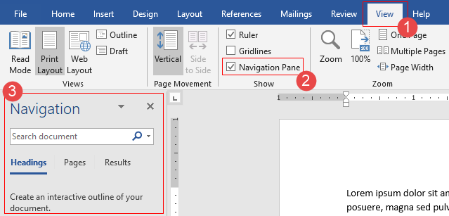

**Step 1:**

Click the **View** tab in the Ribbon.

**Step 2:**

Check the “Navigation Pane” checkbox in the “Show” button group to turn the Navigation pane ON.

or simply press ***Ctrl+F***.in keyboard.

By default, the “Navigation Pane" appears on the left side of the application window *(see point 3 in above picture)*. You can move to the right side by drag.

There are three tabs in the Navigation Pane, those are Heading, Pages and Search. Now we are describing each tab in details.

# Heading tab:

In a more page document, it is very toilsome to go one section to another by scrolling pages. If document contains Level or Headings style in any section of document body then those Level and Headings appear in the navigation pane as a document outline. If the document outline consists with sublevel or subheading then it looks like a tree view.

**Note:**

*Please remember that Heading inside table, text box, header and footer doesn't appear in the Heading tab.*

## **01. Create Headings:**

There are two methods to add a Heading in the document:

**Method 1 – Heading Style (Recommended):**

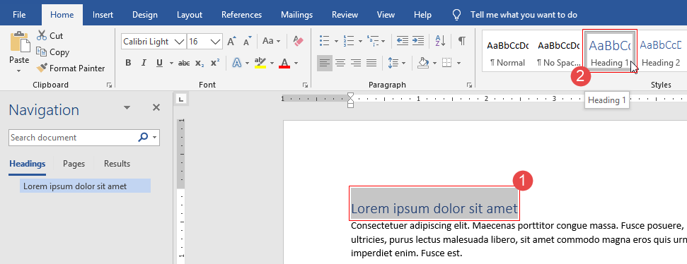

**Step 1:**

Select a line (you can choose multiple lines).

**Step 2:**

Click on the **Heading1** or Heading2 from Styles group of **Home** menu.

**Method 2 – Level:**

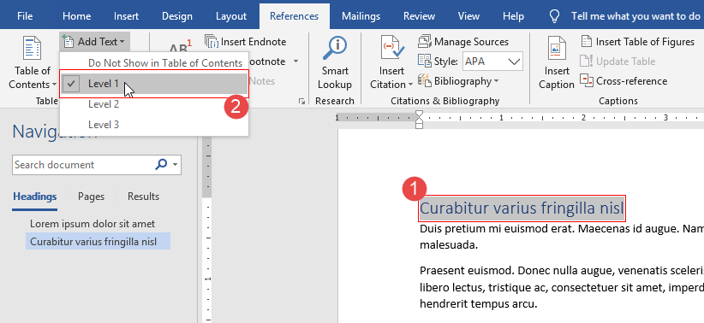

**Step 1:**

Select a line (you can choose multiple lines).

**Step 2:**

Click on the any Level item (1, 2, 3) from Add Text select option field of Reference menu.

## **02. Using Headings tab:**

On the **Navigation Pane**, make sure the **Headings** tab is selected. If you enabled the pane using the checkbox on the View menu, that should be selected automatically. If you open it with **Ctrl+F**, it will show you the **Results** tab by default.

**Moving section to section:**

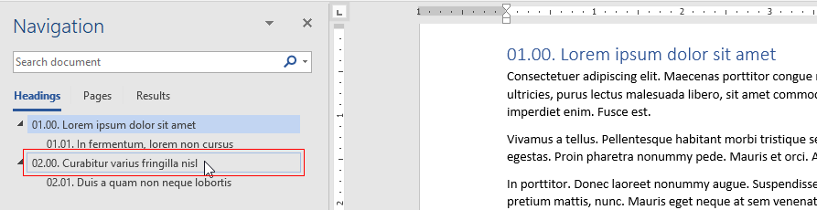

To go to a section of the document just click on the heading of the section in the Navigation pane.

**Collapse/expand the subheadings:**

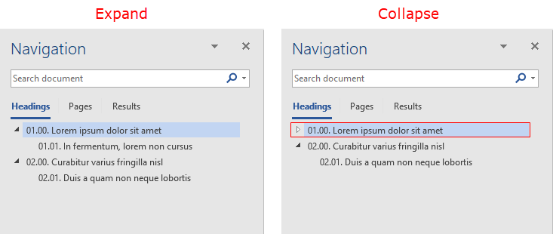

To collapse/expand the subheadings under a heading, click the arrow next to the heading.

**Identifying active heading:**

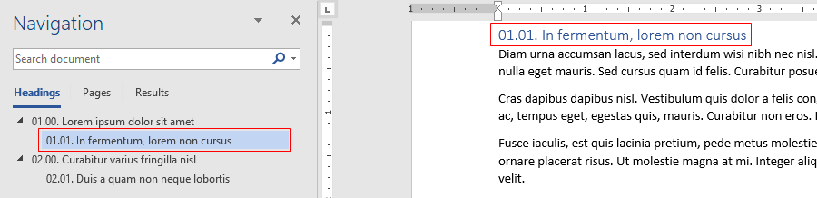

If you scroll through your document, Word highlights the heading in the Navigation pane to show you where you are. To go back to the top, click Jump to the beginning.

## **03. Reorganize your document**

You can move whole section of your document around by moving them in the Navigation pane. Also, it is possible to perform add, edit, or delete operation from the context menu of the navigation pane.

**Moving a section:**

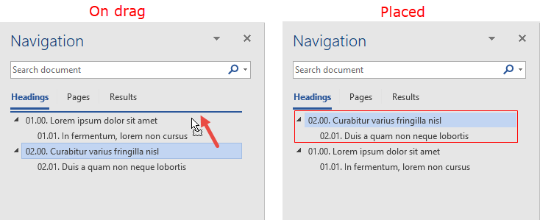

To move a headline and section content, click the heading then drag and drop it into a new location.

**Note:**

*After moving a section, it can be required to rename some sections to make the section order as consistent.*

**Context menu options:**

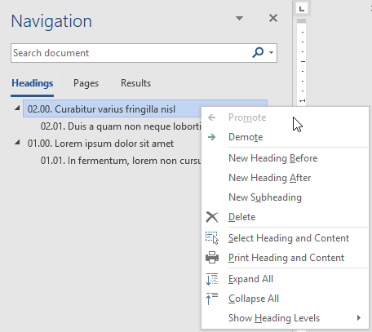

Right-clicking a heading opens a context menu that lets some options to manipulate headings like promote, demote even add or delete headings. So, right-click on the heading, and then choose the action you want.

**Note:**

*When you delete a heading in the navigation pane, Word also deletes all text and objects under that heading—not just the heading section itself. It’s used for removing whole sections of your document.*

# Pages tab:

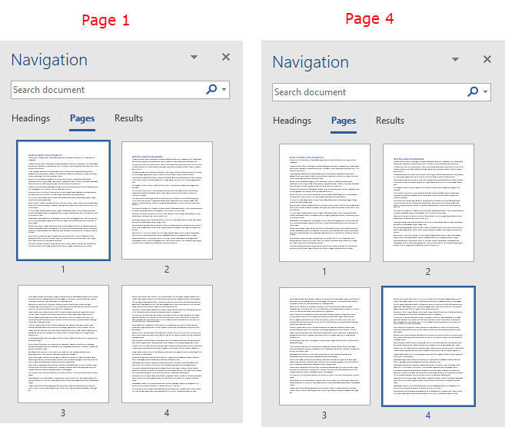

**Step 1:**

After enable the Navigation Pane click on the **Pages** tab. The **Pages** tab shows thumbnail view of each page of the document.

**Step 2:**

Click a thumbnail to display that page in the work area.

# Search box and Results tab:

The **Results** tab lists the results of any search that started in **Search box**. Click any item in the list to move to its location in your document.

**Search box:**

To search within document, enter a search **String** in the Search box at the top of the pane.

Microsoft Word application interactively enacts your search after entering any string in search box but If it doesn’t enact search then click the magnifying glass icon to enact the search manually.

**Result tab:**

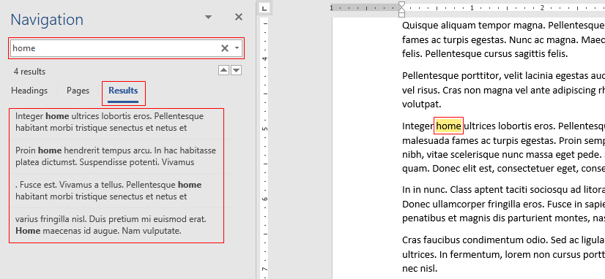

To view a list of search results of a search you started, click the “Results” tab below the Search field in the Navigation pane and, Word will highlight all of the sections where search results appear.

Click any item in this list to move to its location in your document.

**Search result filter option:**

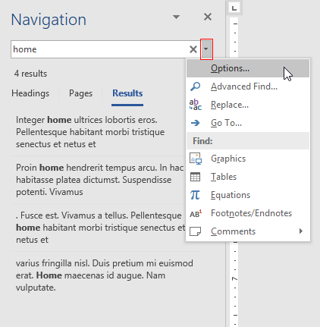

Click the drop-down arrow on the right side of the Search field. It shows search options. For example, you could choose **Tables** to search for only inside table of your document.